Scenarios tested with GitHub copilot

Gives suggestion methods through class name.

For example if we give class name as Stringutils then it will give auto method suggestions like palindrome method, reversing a string etc.,

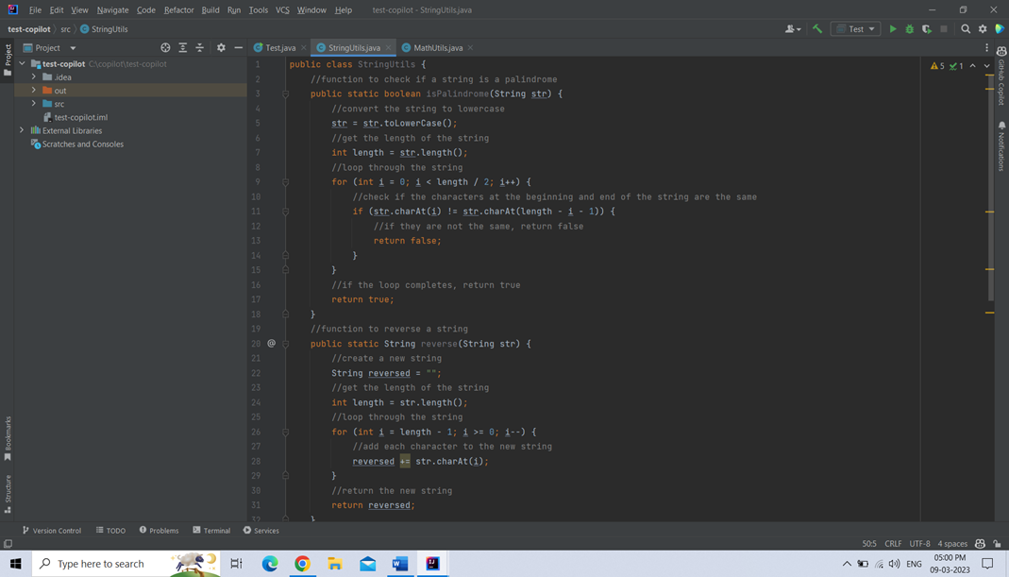

And also tested with Mathutils class then it will give give auto method suggestions like check a number is prime or not, find factorial of a number etc..,

Tested with methods that it will give generate based on comments

For example if we want method with sum of two numbers without return type then it will give give suggested method based on the comments

It will give also generate code for calling another class method if we mention in comments

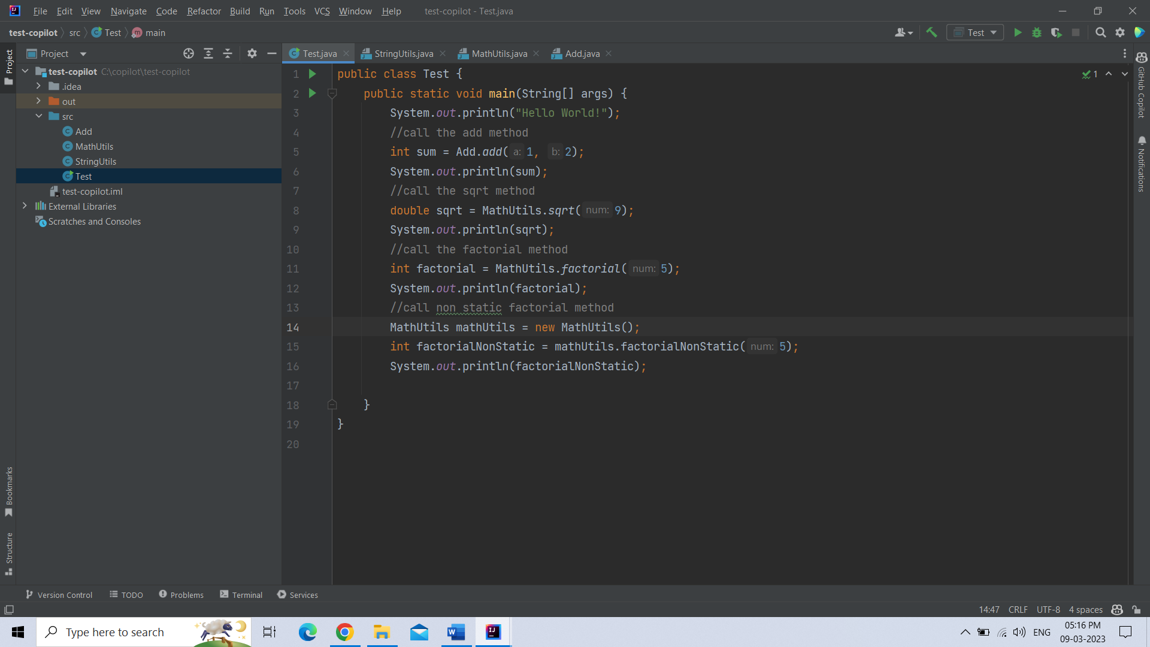

Tested with spring boot application

For example in service class it will give suggesstions for all crud oprations

